Ideation Phase
Define the Problem Statements

Date | 31 January 2025
Team ID | 6AP3D7136F290BE8A6B32917
Project Name | AI FAQ ASSISTANT API
Maximum Marks | 2 Marks

Customer Problem Statement Template
Create a problem statement to understand the customer's point of view. The Customer Problem Statement template helps the team focus on what matters to create useful and effective experiences for users.
A well-articulated customer problem statement allows the team to identify the ideal solution for the challenges faced by customers. Throughout the process, the team can understand the customer's needs, difficulties, expectations, and experience with the existing system.
Reference: https://miro.com/templates/customer-problem-statement/
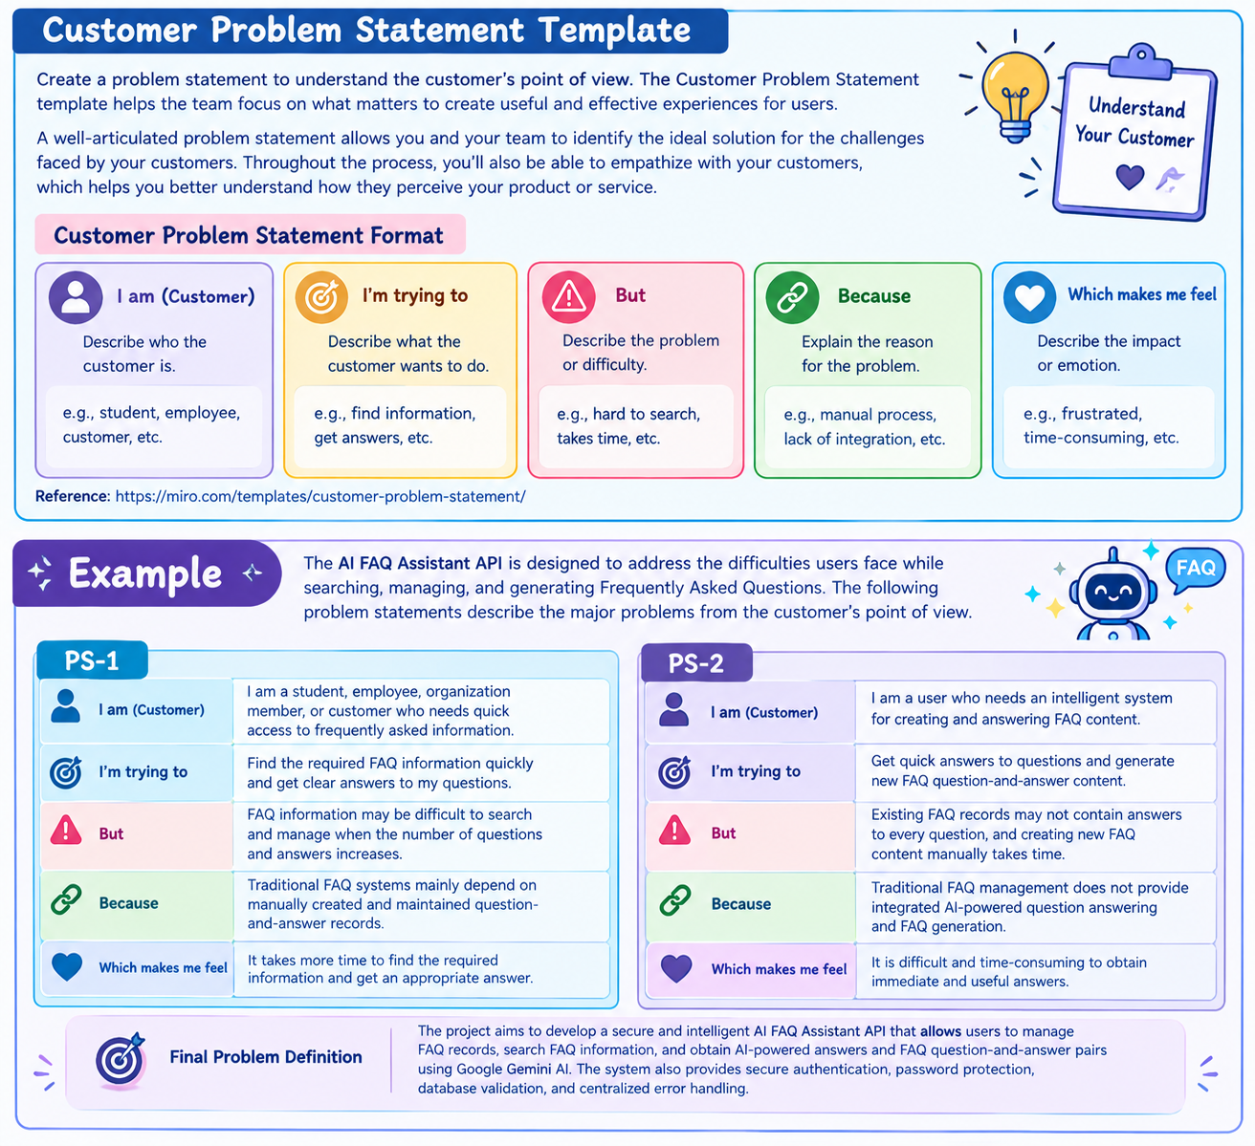

Example
The AI FAQ Assistant API is designed to address the difficulties users face while searching, managing, and generating Frequently Asked Questions. The following problem statements describe the major problems from the customer's point of view.

Problem Statement (PS)

PS-1
Category | Problem Statement
I am (Customer) | I am a student, employee, organization member, or customer who needs quick access to frequently asked information.
I'm trying to | Find the required FAQ information quickly and get clear answers to my questions.
But | FAQ information may be difficult to search and manage when the number of questions and answers increases.
Because | Traditional FAQ systems mainly depend on manually created and maintained question-and-answer records.
Which makes me feel | It takes more time to find the required information and get an appropriate answer.

PS-2
Category | Problem Statement
I am (Customer) | I am a user who needs an intelligent system for creating and answering FAQ content.
I'm trying to | Get quick answers to questions and generate new FAQ question-and-answer content.
But | Existing FAQ records may not contain answers to every question, and creating new FAQ content manually takes time.
Because | Traditional FAQ management does not provide integrated AI-powered question answering and FAQ generation.
Which makes me feel | It is difficult and time-consuming to obtain immediate and usefulanswers.

Final Problem Definition
The project aims to develop a secure and intelligent AI FAQ Assistant API that allows users to manage FAQ records, search FAQ information, and obtain AI-powered answers and FAQ question-and-answer pairs using Google Gemini AI. The system also provides secure authentication, password protection, database validation, and centralized error handling.

